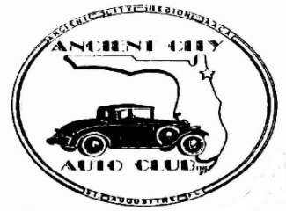 ANCIENT CITY AUTO CLUB 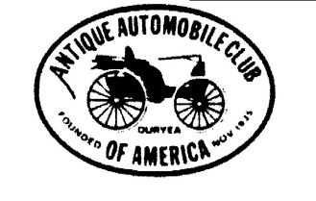
ANCIENT CITY REGION
ANTIQUE AUTOMOBILE CLUB OF AMERICA
MEMBERSHIP APPLICATION
The Ancient City Auto Club is also known as the Ancient City Region of the Antique Automobile Club of America (AACA), America’s oldest and largest automotive historical society. Membership in the AACA provides insurance coverage on requested club activities and events as well as subscriptions to the bi monthly AACA magazine. The annual dues are $65 of which $45 is forwarded to the National AACA and $20 is retained for the Ancient City Region dues.
NOTE: If you are a first-time new member of AACA and not a former member who has allowed his membership to lapse and this application is dated June 1st through Oct 15th then the ½ year membership includes the months June through December at a cost of only $25 for the National AACA and $20 for the Ancient City Region, a saving of $20. Ancient City Region does not discount our annual dues as they help to defray the annual cost of scholarships we award to students at the St. Augustine Technical Center as well as other club activities that occur throughout the year. That means all NEW members applying for membership June 1st through Oct 15th will pay $45 and will be paid to the end of the year.
___________________________________________________________________________
Name______________________________________Date___________________
Spouse/Other________________________________
Are you a current or former paid member of National AACA_____________
If you answered yes please indicate your AACA member number______________
Address ______________________________________________________________
City/State/Zip Code____________________________________________________
Telephone Home_________________________Cell_________________________
Email (used for Club notices) ____________________________________________
Please indicate your consent to use all or your choice of information in the club roster. The club roster is only provided to our members. Please check one:
Publish All or Circle the Acceptable Portions
Special interest vehicles you own
Year Make Model Body Style

Please return this application with payment, making your check payable to ACAC, and mailing to Fred Cooper, 260 Deportivo Drive, St. Augustine, FL 32086-8835.
For membership questions phone Joe Greeves, (904)347-4602

